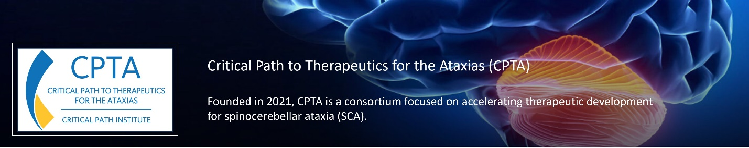
CPTA Mission and Objectives
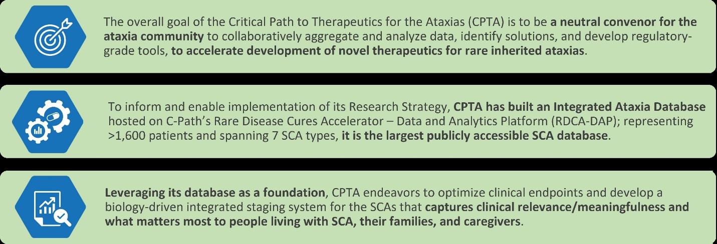
CPTA Research Plan and Impact
The CPTA Research Plan is collaborative, pre-competitive, consensus-based, data driven, and patient-centric and designed to deliver actionable and regulatory grade solutions to address urgent unmet needs, thereby de-risking, and accelerating drug development for rare inherited ataxias.

Harnessing the power of rare disease data
Launched in November 2022, the CPTA Integrated Ataxia Database is comprised of patient-level data from 3 large natural history datasets, all harmonized and fully curated to regulatory data standards. The CPTA database serves the multi-functions of powering the consortium’s Research Plan, informing decision-making and the consortium’s regulatory science strategy, and providing the ataxia community with access to high-quality, patient-level data.
More information on data requests/access here: https://portal.cpta.c-path.org/

Impact Potential for CPTA’s Tools and Solutions
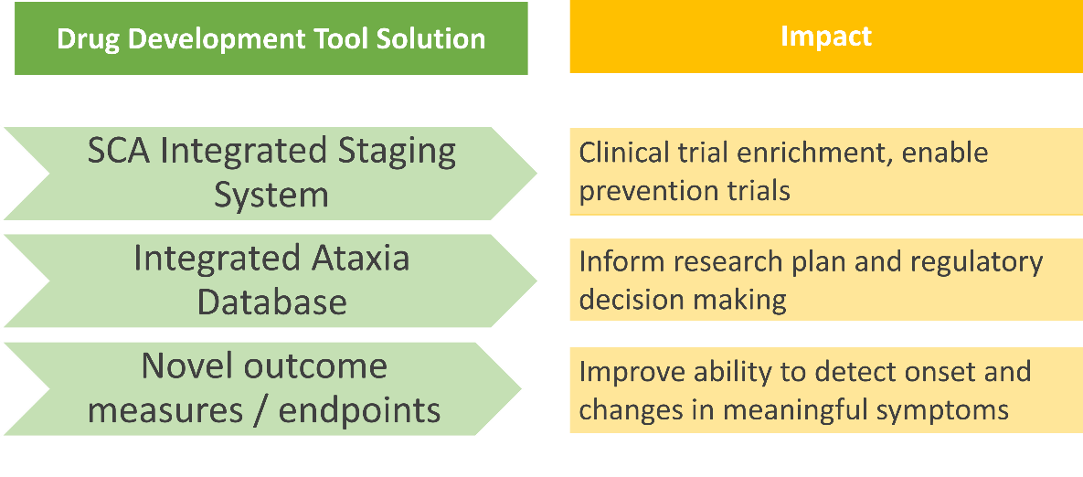

Recent Consortium Highlights and Achievements
- Strategic configuration of CPTA within the new Critical Path for Rare Neurodegenerative Diseases Program (https://c-path.org/program/critical-path-for-rare-neurodegenerative-diseases/)
- Launched the Outcome Measures Working Group
- Convened quarterly industry member strategy meetings to build consensus and hone the consortium’s priorities and strategies
- Ingested, curated, and launched the CRC-SCA natural history dataset in the CPTA Integrated Ataxia Database
- Evaluated the consortium’s initiatives against relevant, new FDA Guidance
  - Patient-Focused Drug Development: Incorporating Clinical Outcome Assessments Into Endpoints for Regulatory Decision-Making (guidance document)
  - Rare Diseases: Considerations for the Development of Drugs and Biological Products (guidance document)
- Commemorated Ataxia Awareness Day on September 25
- Participated in C-Path’s Rare and Orphan Disease annual meeting in Washington, D.C.

CPTA profoundly appreciates its members!
